**What is SDLC**

**SDLC means Software Developer Life Cycle.**

**SDLC is a structure imposed on the development of a software product.**

**SDLC Stap / Phases :**

1 : **Requirement** - First of all we should know what is the customer's Requirment.

2 : **Analysis** - If Customer is agree then do analysis on his requirment.

3 : **Design** - After Analysis developer create its design.

4 : **Coding / Implementation** - After design consruct an implementation software.

5 : **Testing** - After Implimentation Starts the Testing.

6 : **Maintenance** - Last one maintentance is necessary in all website.

**What is Software Testing**

Software Testing is a process used to identify the **Correctness, Completeness** and **Quality** of developed computer software.

Type of Testing :

1 : **Static Testing** – Without executing code……Check only design & document.

2 : **Dynamic Testing** – with executing code……Check all Application

**What Is Agile Methodology**

Agile Model / Methodology is a combination of iterative and intermantal model. Agile model breaks into small incremental build.

**Pros (Advantage) of Agile Model** :

1 : It’s a realistic model.

2 : Team work is compulsory.

3 : Minimum resource are required.

4 : Good model for environment which change freqvantly.

5 : Easy to manage.

6 : Give flexibility to evelopers.

7 : No planning required.

**Cons (Disadvantage) of Agile Model :**

1 : Not suitable for handling complex (difficult) dependencies.

2 : More risk you have to manage strict delivery management.

3 : Its totally depended on customer’s feedback.

**What is SRS ?**

SRS means software requirements specification . SRS is a complete description of the behavior of the

system to be developed.

**Type of SRS Requirments :**

1 Customer Requirements

2 Functional Requirements

3 Non-Functional Requirement

1 **Customer Requirement :** The customers are those that perform the eight primary functions of systems engineering, with special emphasis on the operator as the key customer.

2 **Functional Requirements** : Functional requirements are very important system requirements in the system design process. These requirements are the technical specifications, system design parameters and guidelines.

3 **Non-Functional Requirement** : Non-functional requirements are requirements that specify criteria that can be used to judge the operation of a system, rather than specific behaviors.

**What is OOPS ?**

**OOPS means Object Oriented Programming. An Object based programming language is one which easily supports object orientation.**

**Write Basic Concept of OOPS**

**Identifying objects and assigning responsibilities to these objects. An internal details are hidden and just showing output.**

**EX. Gift Box.**

Features of OOP:

1 : Object

2 : Class

3 : Abstraction

4 : Encapsualtion

5 : Inheritance

6 : Polymorphism

**What is Object?**

**Object** means any entity which has own state and behaviour.

Ex.Any living things like Flower or tree or animal.

**What is Class?**

**Class** means Collection of objects.

Ex. Human Body.

**What is Encapsulation ?**

**Encapsualtion** means Binding of data or wrapping up of data.

Ex. Capsule of medicine.

**What is Inheritance?**

**Inheritance** means When one object acquire all the properties and behaviour of parent class.

Ex. Father-son

**What is Polymorphism ?**

**Polymorphism** means Many way to perform anything.

Ex. 1 Method overloadnig. 2 Method overriding.

**Draw Usecase on Online Book Shoping**

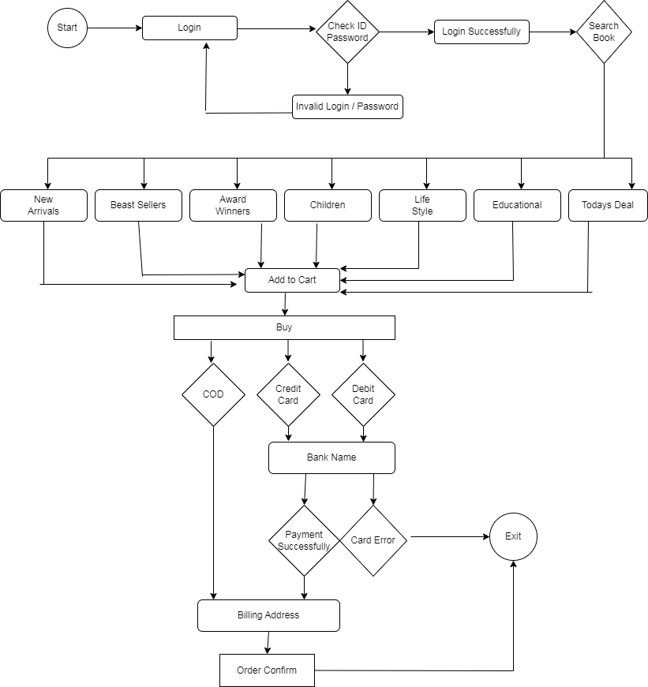

**Draw Usecase on Online Bill Payment System**

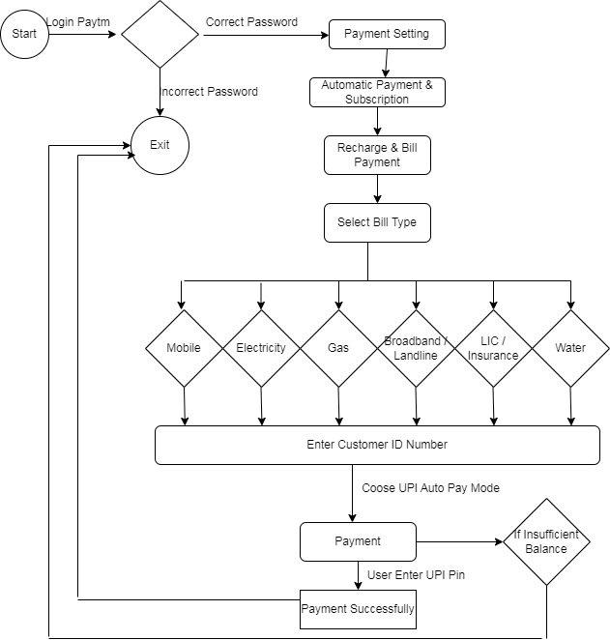

**Write SDLC Phases with Basic Introduction**

**SDLC Stap / Phases :**

1 : **Requirement** - First of all we should know what is the customer's Requirment.

2 : **Analysis** - If Customer is agree then do analysis on his requirment.

3 : **Design** - After Analysis developer create its design.

4 : **Coding / Implementation** - After design consruct an implementation software.

5 : **Testing** - After Implimentation Starts the Testing.

6 : **Maintenance** - Last one maintentance is necessary in all website.

**Explain Phases of The Waterfall Model**

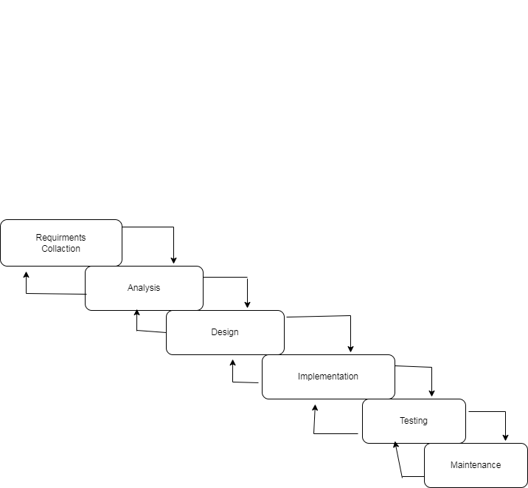

**Write Phases of Spiral Model**

Spiral Model auther’s name is Bohem. That’s why its called Bohem’s Spiral Model.

**Phases of Spiral Model :**

1 : **Planning** : Determination of objectives, alternatives and constraints**.**

2 : **Risk Analysis** : Analysis of alternatives and identification / resolution of risk.

3 : **Engineering** : Development of the “next level “ product.

4 : **Customer Evaluation** : Assessment of engineering.

**Explain Working Methodology Of Agile Model And Also Write Pros & Cons**

Agile Model / Methodology is a combination of iterative and intermantal model. Agile model breaks into small incremental build.

**Pros (Advantage) of Agile Model** :

1 : It’s a realistic model.

2 : Team work is compulsory.

3 : Minimum resource are required.

4 : Good model for environment which change freqvantly.

5 : Easy to manage.

6 : Give flexibility to evelopers.

7 : No planning required.

**Cons (Disadvantage) of Agile Model :**

1 : Not suitable for handling complex (difficult) dependencies.

2 : More risk you have to manage strict delivery management.

3 : Its totally depended on customer’s feedback.

**Draw Usecase on Online Shopping Product Using COD**

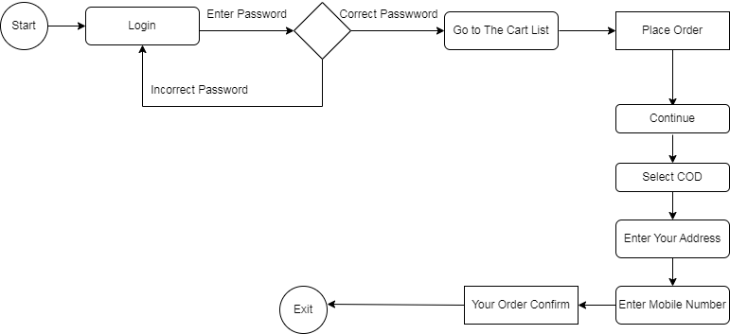

**Draw Usecase on Shopping Product Using Payment Gateway**

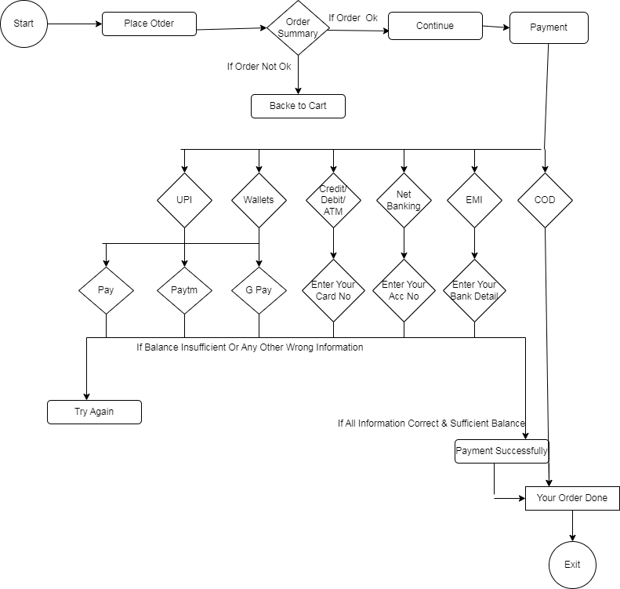

**END**